**Labour claims largest majority ever in post-independence history**

**Labour claims majority of 55% as PN concedes defeat with 44% of the vote**

10 March 2013, 12:00am

Joseph Muscat's ballots on the second district clearly eclipse Nationalist leader Lawrence Gonzi's in quantity. Photo: James Galea/Mediatoday

[TWEET](https://twitter.com/share?url=https://www.maltatoday.com.mt/news/elections2013/25287/labour-wins-pn-concedes-defeat-20130310&text=Labour%20claims%20largest%20majority%20ever%20in%20post-independence%20history) [SHARE](http://www.facebook.com/sharer.php?s=100&p%5burl%5d=https://www.maltatoday.com.mt/news/elections2013/25287/labour-wins-pn-concedes-defeat-20130310)

The Labour Party has claimed victory in the 2013 election after only a few minutes into the counting process itself.

At a reported 55% majority, the landslide victory separates Labour from the Nationalists by around 30,000 votes - the largest majority ever in post-independence Malta.

Party sources believe the majority of votes could be as high as 36,000, while Green Party Alternattiva Demokratika could be set for its highest ever national result with 1.8%. Percentages are still unofficial.

A great cheer went up among Labour officials and supporters inside the counting hall, as the first samples delivered a clear Labour victory. Chants of 'Taghna Lkoll', the Labour electoral slogan echoed throughout the entire counting hall.

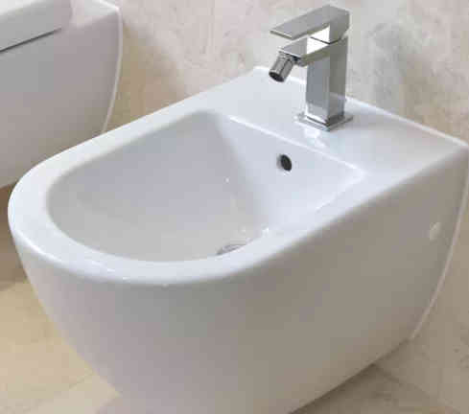

MaltaToday is also informed that Prime Minister Lawrence Gonzi has called Labour leader Joseph Muscat to inform him that the Nationalist Party was conceding the election to Labour, and to congratulate him on his victory.

PN secretary general Paul Borg Olivier also announced that the Nationalist Party was conceding the election to Labour.

While the election result is still unknown, analysts are currently pointing towards a Labour landslide given how early the result was called by both parties. AD officials are reported as saying that the result for AD does not look good.

The figures currently doing the rounds place Labour at 55% and the PN at 44%, constituting a gap of 11% - an advantage predicted by MaltaToday's own polls. This translates to approximately 30,000 votes.

LINK: <https://www.maltatoday.com.mt/news/elections2013/25287/labour-wins-pn-concedes-defeat-20130310#.WvRSFX8h1pg>